General remarks:
- Avoid using too much bold in your text, only when you introduce a new term for example

Chapter 5: A Knowledge Graph-Driven Framework for Automatic ESG Report Generation

5.1 Introduction
The transition of ESG reporting from voluntary disclosure to mandatory compliance has created unprecedented challenges for organizations worldwide. Regulatory developments such as the EU’s Corporate Sustainability Reporting Directive (CSRD) (European Commission, 2022) and the IFRS Sustainability Disclosure Standards (IFRS Foundation, 2023a, 2023b) have significantly increased the complexity of ESG disclosures, forcing companies to align diverse metrics across multiple frameworks simultaneously. Organizations face persistent challenges including aligning heterogeneous standards (Eccles & Klimenko, 2020), integrating siloed data across disparate systems (Serafeim & Yoon, 2020), documenting calculation logic transparently (Christensen et al., 2021), and ensuring complete traceability from raw data to final reported metrics (Berg et al., 2022). These issues fundamentally undermine report reliability, stakeholder trust, and regulatory compliance, with empirical studies showing that only 20% of companies demonstrate complete data lineage in their ESG metrics (Cooper et al., 2021).
Service-oriented architectures (SOA) and knowledge graphs (KG) have independently demonstrated powerful capabilities for building modular, adaptable, and transparent systems. SOA decomposes complex workflows into loosely coupled, well-defined services, improving maintainability and scalability (Ozkaya, 2023; Newman, 2021), while knowledge graphs model domain knowledge explicitly through semantic relationships, enabling advanced reasoning, traceability, and integration of heterogeneous data sources (Hogan et al., 2021; Noy et al., 2019). Combining SOA and KG creates service-oriented knowledge graph architectures that support interactive, adaptable workflows driven by semantic understanding—an approach increasingly relevant in domains where regulatory requirements, data relationships, and calculation logic evolve rapidly.
This chapter presents a comprehensive framework that operationalizes the ESG Metric Knowledge Graph (ESGMKG) ontology introduced in Chapter 4. While Chapter 4 established the conceptual foundation comprising eight core entities and eight semantic relationships, this chapter focuses on the service-oriented architecture that transforms this ontology into an operational system. The framework provides systematic support for three core use cases: automated report generation aligned with regulatory frameworks, transparent metric calculation with full provenance tracking, and comprehensive data access with complete lineage documentation. Through evaluation on a dataset comprising 422,833 records from 40 companies across nine years, the framework demonstrates responsive performance and practical applicability in real-world reporting tasks (Qin et al., 2025).
The key contributions of this chapter are threefold. First, it demonstrates the application of knowledge graph-driven approaches to ESG reporting, automating workflows with improved efficiency and transparency. Second, it proposes a novel four-layer service-oriented architecture that integrates the ESGMKG knowledge graph with modular services and semantic reasoning capabilities. Third, it validates the system on real, large-scale ESG data, demonstrating scalability, adaptability, and full traceability aligned with frameworks such as SASB (SASB, 2018).
The remainder of this chapter is organized as follows. Section 5.2 presents the functional requirements and use cases. Section 5.3 details the four-layer service-oriented architecture. Section 5.4 describes the reasoning mechanisms. Section 5.5 covers the implementation details. Section 5.6 presents a case study demonstration. Section 5.7 provides comprehensive evaluation including performance metrics and TAT assessment. Section 5.8 concludes with a summary and future directions.

5.2 Requirements and Use Cases

5.2.1 Functional Requirements
The framework addresses four fundamental requirements that emerged from analysis of current ESG reporting challenges. The first requirement concerns framework alignment, where the system must automatically identify applicable reporting frameworks based on industry classification and dynamically map organizational data to framework-specific disclosure requirements. This capability addresses the challenge organizations face when navigating multiple overlapping standards such as SASB, GRI, and CSRD, each with distinct metric definitions and reporting boundaries.
The second requirement focuses on metric transparency, ensuring that every reported metric value can be traced to its calculation methodology and underlying data sources. This transparency is essential for audit readiness and stakeholder confidence, particularly as regulations increasingly mandate disclosure of calculation assumptions and data provenance (Buneman et al., 2001). The system must expose not only the final metric values but also the complete reasoning chain from raw data through intermediate calculations to final reported figures.
The third requirement addresses data integration across heterogeneous sources with varying formats, temporal granularities, and semantic definitions. ESG data typically resides in multiple enterprise systems including ERP platforms, environmental monitoring systems, HR databases, and external data providers (Lenzerini, 2002). The framework must provide unified access to these disparate sources while preserving source attribution and enabling consistent aggregation across organizational boundaries.
The fourth requirement emphasizes adaptability to evolving standards without requiring fundamental system modifications. As ESG frameworks continue to evolve and converge, the system architecture must support the addition of new metrics, modification of calculation methodologies, and incorporation of emerging disclosure requirements through configuration changes rather than code modifications (Dragoni et al., 2017).
Table 5.1 summarizes these requirements and their mapping to system capabilities enabled by the competency questions (CQ1–CQ7) defined in Chapter 4.
Table 5.1: Functional Requirements and System Capabilities
Requirement | Description | System Capability
Framework Alignment | Automatic identification of applicable frameworks | Knowledge graph-based industry-framework mapping via CQ1–CQ3
Metric Transparency | Complete traceability of calculations | Semantic provenance tracking through CQ4–CQ7
Data Integration | Unified access to heterogeneous sources | Service-oriented data retrieval with metadata preservation
Adaptability | Support for evolving standards | Ontology-driven configuration without code changes

5.2.2 Use Case Specifications
The framework supports three core use cases that address the primary workflows in ESG reporting: report generation, metric calculation, and data access. These use cases reflect core challenges faced by ESG practitioners, including the need to align disclosures with regulatory frameworks, compute metrics with transparent logic, and trace data lineage back to original sources. Each use case is enabled by the competency questions (CQ1–CQ7) that leverage the ESGMKG ontology defined in Chapter 4.
Use Case 1: ESG Report Generation. This use case automates the production of ESG reports aligned with relevant reporting frameworks. The workflow begins when a user selects an industry classification, triggering the system to identify applicable reporting frameworks through CQ1. For each framework, the system retrieves associated categories via CQ2 and enumerates the metrics within each category using CQ3. The report generation process then invokes Use Case 2 (Metric Calculation) for each required metric, assembling results into a structured disclosure document that maintains complete provenance information.
Use Case 2: Metric Calculation. This use case supports the transparent computation of individual ESG metrics according to how they are defined in the ESGMKG. When a metric calculation is requested, the system first determines whether the metric value is obtained directly from a dataset variable or requires model-based computation through CQ4. For model-based metrics, the system retrieves required input metrics via CQ5 and identifies the appropriate implementation through CQ6. This recursive process ensures that nested metric dependencies are resolved transparently, and the final value is accompanied by a complete chain of reasoning and inputs.
Use Case 3: Data Access. This use case traces the raw sources of metric inputs through direct access to ESG datasets and metadata. For each dataset variable involved in a metric, the system invokes CQ7 to identify its original data source. By linking metrics to original data with timestamp and unit information, this use case enhances stakeholder trust and supports compliance audits through complete data lineage.
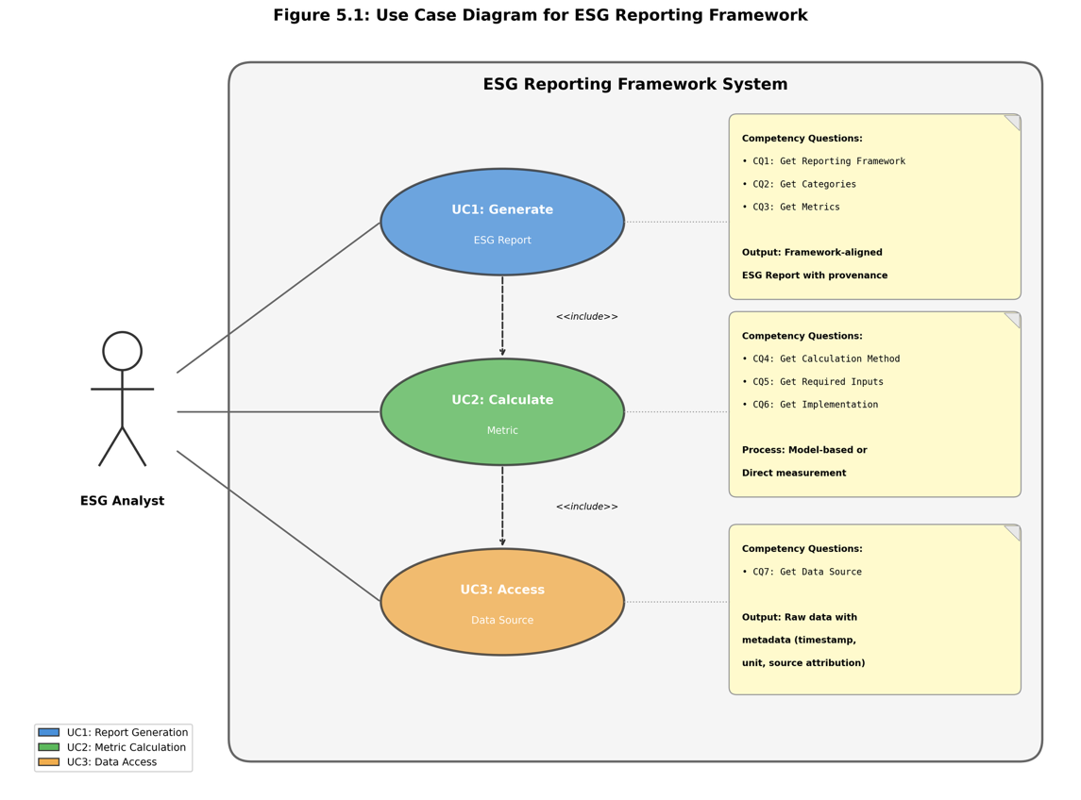
FIGURE 5.1: Use Case Diagram showing the three core ESG reporting use cases (UC1: Report Generation, UC2: Metric Calculation, UC3: Data Access) and their relationships to competency questions CQ1–CQ7
Table 5.2 provides the detailed mapping between use cases and competency questions.
Table 5.2: Use Case to Competency Question Mapping
Use Case | CQs Used | Purpose
UC1: Report Generation | CQ1 | Identify applicable reporting frameworks for industry
 | CQ2 | Retrieve categories within the framework
 | CQ3 | Enumerate metrics belonging to each category
UC2: Metric Calculation | CQ4 | Determine calculation method (model or direct)
 | CQ5 | Identify required input metrics for model
 | CQ6 | Locate executable model implementation
UC3: Data Access | CQ7 | Trace dataset variable to original data source

5.3 Four-Layer Service-Oriented Architecture

5.3.1 Architecture Overview
To support the Use Cases, the framework is supported by a service-oriented knowledge graph architecture comprising four distinct layers: the Presentation Layer, API Gateway Layer, Service Layer, and Data Layer. This modular design separates concerns while enabling scalability, maintainability, and extensibility (Parnas, 1972). Each layer encapsulates specific responsibilities and communicates through well-defined interfaces, allowing independent evolution and deployment of components.
The architecture combines the strengths of service-oriented design with semantic knowledge representation. The service-oriented approach provides loose coupling between components, enabling independent scaling and maintenance of individual services (Richardson, 2018). The ESGMKG knowledge graph, whose schema is detailed in Chapter 4, provides a formal semantic foundation that supports reasoning, traceability, and adaptation to evolving requirements without code modifications. This combination creates a system that is both operationally robust and semantically rich.
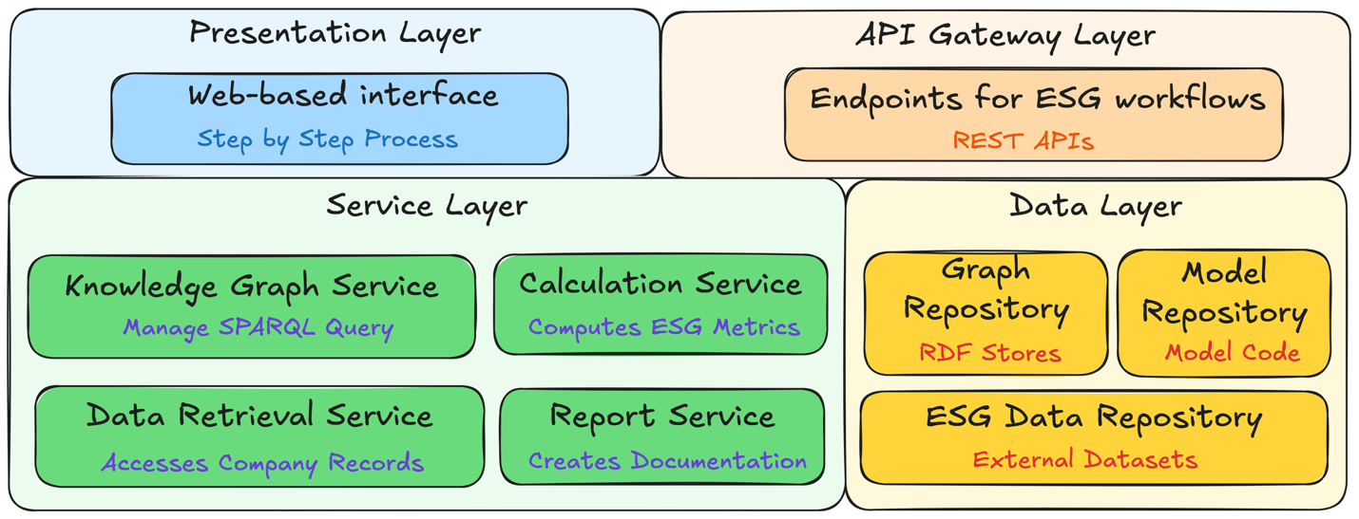
FIGURE 5.2: Four-Layer Service-Oriented Knowledge Graph Architecture comprising Presentation Layer (Web-based Interface), API Gateway Layer (REST APIs), Service Layer (Knowledge Graph, Data Retrieval, Calculation, and Report Services), and Data Layer (Graph Repository, Model Repository, ESG Data Repository)

5.3.2 Presentation Layer
The Presentation Layer provides a web-based interface guiding users through ESG report generation workflows. This layer enables industry and framework selection, category exploration, metric calculation, and review of generated reports, aligning user interactions with the underlying semantic model. The interface implements a step-by-step workflow that mirrors the logical progression of ESG reporting: selecting an organizational context, identifying applicable frameworks, exploring disclosure categories, computing metric values, and generating final reports.
The interface design emphasizes transparency by exposing the semantic structure underlying each reporting decision. When users select an industry, the interface displays the reasoning chain that identifies applicable frameworks. During metric calculation, users can inspect the calculation methodology, input dependencies, and data sources for each metric. This transparency supports user understanding and facilitates audit review of generated reports.

5.3.3 API Gateway Layer
The API Gateway Layer acts as an abstraction layer between the user-facing presentation interface and the system’s analytical services. It provides a unified entry point for all ESG reporting workflows, standardizing communication between frontend and backend components (Fowler, 2002). By encapsulating requests and responses, it maintains modularity, improves system security through centralized authentication and authorization, and facilitates future integration with external tools or platforms.
The gateway implements ten service-oriented endpoints that expose the framework’s capabilities through RESTful APIs. These endpoints are organized by functional domain: Knowledge Graph Service endpoints for semantic queries, Data Retrieval Service endpoints for dataset access, Calculation Service endpoints for metric computation, and Report Service endpoints for document generation. Table 5.3 summarizes these endpoints and their functions.
Table 5.3: Core Service-Based API Endpoints
Service | Endpoint | Primary Role
Knowledge Graph | /api/KGservice/industries | Industry enumeration
 | /api/KGservice/industries/{id}/frameworks | Discover applicable frameworks
 | /api/KGservice/frameworks/{id}/categories | Retrieve reporting categories
 | /api/KGservice/categories/{id}/metrics | List metrics by category
Data Retrieval | /api/DRservice/industries/{id}/companies | Company listing from dataset
 | /api/DRservice/companies/{id}/years | Available years for company
 | /api/DRservice/data-availability/{c}/{y} | Validate company-year data
 | /api/DRservice/data-availability/bulk | Bulk data availability check
Calculation | /api/CSservice/calculate | Perform ESG metric calculation
Report | /api/RSservice/reports/generate | Generate ESG report with provenance

5.3.4 Service Layer
The Service Layer hosts specialized components that drive the system’s core analytical capabilities. Four primary services collaborate to deliver end-to-end ESG reporting functionality: the Knowledge Graph Service, Data Retrieval Service, Calculation Service, and Report Service. Each service encapsulates distinct responsibilities, improving clarity, maintainability, and enabling seamless extensions (Gamma et al., 1995).
The Knowledge Graph Service executes competency questions CQ1–CQ7 via live SPARQL queries against the ESGMKG ontology. This service translates high-level semantic queries into SPARQL operations (Harris et al., 2013), returning structured results that inform workflow decisions. The service maintains connection pooling for efficient query execution and implements caching for frequently accessed ontology patterns.
The Data Retrieval Service accesses external ESG datasets and preserves provenance metadata. This service handles large-scale data access and filtering, returning not only requested values but also metadata including timestamps, units, and source identifiers. The service implements data validation to ensure completeness before metric calculations proceed.
The Calculation Service orchestrates metric computations through transparent, traceable processes. For each metric request, the service determines whether direct measurement or model-based calculation is required, retrieves necessary inputs, executes appropriate implementations, and returns results with complete provenance information. The service supports recursive resolution of metric dependencies through the calculation dependency graph.
The Report Service assembles framework-compliant ESG reports that maintain end-to-end data lineage. This service aggregates metric values, calculation metadata, and provenance information into structured disclosure documents. The service supports multiple output formats and includes validation against framework-specific requirements.

5.3.5 Data Layer
The Data Layer stores the ESG knowledge graph, external ESG datasets, and a model repository containing reusable implementations for metric computation. Together, these components provide the semantic backbone and data foundation necessary for automated, transparent ESG reporting.
- The Graph Repository contains the ESGMKG ontology implemented as an RDF triple store. The knowledge graph encodes semantic relationships among key reporting concepts as defined in Chapter 4, including industries, reporting frameworks, categories, metrics, calculation models, dataset variables, and data sources. The repository supports SPARQL-based query execution for all competency questions and maintains consistency through OWL reasoning and SHACL constraint validation (Knublauch & Kontokostas, 2017).
- The ESG Data Repository stores structured datasets from multiple external sources. The current implementation includes environmental, social, and governance data from the EUROFIDAI Clarity AI ESG database (EUROFIDAI, 2023) and financial data from WRDS (WRDS, 2023) to support intensity calculations. The repository maintains data organized by industry sector with appropriate indexing for efficient retrieval.
- The Model Repository contains reusable metric calculation implementations. Each model is registered in the knowledge graph with metadata describing its inputs, outputs, and execution requirements. The repository supports dynamic model loading and execution, enabling new calculation methodologies to be added through knowledge graph updates without code modifications.

5.4 Reasoning Mechanisms

5.4.1 Overview of Reasoning Approaches
The framework employs four complementary reasoning mechanisms to support ESG reporting workflows: ontological reasoning, rule-based reasoning, path-based reasoning, and constraint-based validation. These mechanisms operate on the ESGMKG ontology to derive implicit knowledge, validate data consistency, and support complex analytical queries that would be difficult to express through simple data retrieval (Baader et al., 2003).
Table 5.4 summarizes the reasoning mechanisms and their applications in the framework.
Table 5.4: Reasoning Mechanisms and Applications
Mechanism | Technology | Application | Example
Ontological | OWL/RDFS | Class hierarchy inference | Industry subclass relationships
Rule-Based | SWRL/Custom | Metric derivation | Intensity metric calculation
Path-Based | SPARQL Paths | Dependency traversal | Multi-hop metric lineage
Constraint | SHACL | Data quality assurance | Required property validation

5.4.2 Ontological Reasoning
Ontological reasoning leverages the formal semantics of OWL and RDFS to derive implicit class memberships and property relationships. The ESGMKG ontology defines class hierarchies that enable automatic classification of entities based on their properties (Hitzler, 2021). For example, the ontology defines industry classifications where specific sectors (e.g., Semiconductor Manufacturing) are subclasses of broader categories (e.g., Technology Hardware), enabling queries at multiple levels of granularity.
The framework uses ontological reasoning to support framework applicability determination. When a user selects an industry, the reasoner traverses the class hierarchy to identify not only frameworks directly associated with that industry but also frameworks applicable to parent industry categories. This inheritance mechanism ensures comprehensive framework coverage without requiring explicit enumeration of all industry-framework relationships.

5.4.3 Rule-Based Reasoning
Rule-based reasoning enables the derivation of computed metric values from input measurements through formally specified calculation rules. The framework implements calculation rules that specify how derived metrics are computed from base measurements (Horrocks et al., 2004). These rules are represented in a declarative format that separates calculation logic from procedural implementation, supporting transparency and auditability.
Algorithm 5.1 presents the rule-based metric calculation process that implements the dual derivation paths (calculated via model or obtained directly from dataset variable) defined in the ESGMKG schema.
Algorithm 5.1: Rule-Based Metric Calculation
Input: Metric m, Company c, Year y
Output: Calculated value v with provenance P
1. method ← GetCalculationMethod(m) // CQ4
2. IF method = DirectMeasurement THEN
3. var ← GetDatasetVariable(m)
4. v ← RetrieveValue(var, c, y) // CQ7
5. P ← CreateProvenance(var, source, timestamp)
6. ELSE
7. model ← GetModel(m)
8. inputs ← GetRequiredInputs(model) // CQ5
9. FOR each input in inputs DO
10. (vᵢ, Pᵢ) ← CalculateMetric(input, c, y) // Recursive
11. END FOR
12. impl ← GetImplementation(model) // CQ6
13. v ← Execute(impl, {vᵢ})
14. P ← AggregateProvenance({Pᵢ}, model)
15. END IF
16. RETURN (v, P)

5.4.4 Path-Based Reasoning
Path-based reasoning employs SPARQL property paths to traverse complex relationships in the knowledge graph. This mechanism is particularly valuable for tracing metric dependencies across multiple hops, identifying all data sources that contribute to a computed metric, and discovering framework relationships through intermediate entities (Ristoski & Paulheim, 2016).
The framework uses property paths to implement comprehensive lineage queries. For example, tracing the complete provenance of an intensity metric requires traversing from the metric through its calculation model, to input metrics, through their respective models or direct measurements, and finally to original data sources. Property path expressions enable this traversal in a single query.

5.4.5 Constraint-Based Validation
Constraint-based validation uses SHACL shapes to ensure data quality and ontology conformance throughout the reporting workflow (Knublauch & Kontokostas, 2017). SHACL constraints define requirements for valid ESG data including required properties, value ranges, cardinality restrictions, and cross-entity consistency rules. The validation engine evaluates incoming data against these constraints before processing, preventing invalid data from propagating through calculations.
The framework implements validation at multiple points in the workflow. Input validation ensures that company-year combinations have required data availability before calculation proceeds. Calculation validation verifies that computed values fall within expected ranges and that all required inputs were successfully retrieved. Output validation confirms that generated reports include all required disclosures for the selected framework.

5.5 Implementation

5.5.1 Technology Stack
The framework implementation employs a modern technology stack optimized for semantic processing and scalable service delivery. Table 5.5 summarizes the key technologies used in each architectural layer.
Table 5.5: Implementation Technology Stack
Layer | Technology | Purpose
Presentation | HTML/CSS/JavaScript | Interactive web interface
API Gateway | Flask/Python | RESTful endpoint exposure
Service Layer | RDFLib | Local RDF processing
 | Apache Jena Fuseki | SPARQL query execution
 | pandas | Large-scale data processing
Data Layer | GraphDB/RDF Store | Knowledge graph persistence (Bishop et al., 2011)
 | CSV/Parquet | Structured ESG datasets

5.5.2 Knowledge Graph Implementation
5.5.2.1 ESG Data repository
What datasets are you using in your implementation ?

5.5.2.2 Model repository
What models are you using in your implementation ?
5.5.2.3 Graph repository
The ESGMKG is implemented as an RDF triple store containing over 650 semantic triples across eight ontology classes. The current instantiation includes 53 metrics, 14 categories, 6 models, and 6 executable implementations aligned with the SASB framework for the Semiconductor and Commercial Banking sectors. The knowledge graph supports SPARQL-based query execution for all competency questions (CQ1–CQ7) as specified in Chapter 4.
The ontology implementation follows the design patterns established in Chapter 4. Each entity is represented as an RDF resource with appropriate class membership and property assertions. The eight semantic relationships (ReportsUsing, Includes, ConsistsOf, IsCalculatedBy, RequiresInputFrom, ExecutesWith, ObtainedFrom, SourcesFrom) enable end-to-end traceability from industry-level reporting requirements down to specific data fields.

5.5.3 Service Implementation
All services are implemented in Python with appropriate libraries for their specific functions. The Knowledge Graph Service uses RDFLib for local graph operations and communicates with Apache Jena Fuseki for complex SPARQL queries requiring reasoning support. The Data Retrieval Service employs pandas for efficient processing of large ESG datasets, implementing filtering, aggregation, and validation operations.
The Calculation Service implements metric computation through a modular design that separates calculation logic from execution infrastructure. A Python-based model repository implements six reusable metric calculation functions, distributed across three modular files for energy, water, and waste metrics. These models are dynamically linked to the knowledge graph for traceable, runtime execution. The service supports both direct measurement retrieval and model-based calculation with recursive dependency resolution.
The Report Service compiles metric outputs and provenance metadata into structured formats. The service generates reports that include metric values, calculation methodologies, input sources, and complete data lineage for each disclosed figure. Output formats support both human-readable presentation and machine-processable structures for downstream integration (Sporny et al., 2014).

5.5.4 Data Integration
The framework integrates structured ESG datasets from multiple authoritative sources. The primary data source is the EUROFIDAI Clarity AI ESG database (EUROFIDAI, 2023), which provides comprehensive environmental, social, and governance metrics for publicly traded companies. The current implementation includes 105,528 environmental records for semiconductors and 317,305 for commercial banks. Financial data from WRDS (WRDS, 2023) supplements the ESG data to support intensity calculations that normalize environmental metrics by revenue or other financial measures.
Data integration preserves source attribution and temporal metadata throughout the processing pipeline. Each data point maintains references to its original source, extraction timestamp, and any transformations applied during integration. This metadata flows through calculations to appear in final report provenance, enabling complete audit trails from reported figures to raw source data.
5.5.4 Presentation Layer
Describe the 2 UIs here before the base study

5.6 Case Study: Semiconductor Industry ESG Report

5.6.1 Scenario Description
This case study demonstrates the framework’s capabilities through generation of an ESG report for a semiconductor manufacturing company. The scenario follows a sustainability analyst preparing annual disclosures aligned with the SASB Semiconductor framework (SASB, 2018). The analyst requires computation of greenhouse gas emissions metrics, energy consumption figures, and derived intensity metrics, with complete documentation of calculation methodologies and data sources for audit purposes.
You need to say that the case study uses the KG described in 5.5.2.3
The case study exercises all three use cases and the full range of competency questions. Report generation (UC1) drives the overall workflow, invoking metric calculation (UC2) for each required disclosure and data access (UC3) for underlying measurements. The demonstration illustrates how the framework automates previously manual processes while maintaining the transparency and traceability required for regulatory compliance.

5.6.2 Interactive Web Interface
Figure 5.3 presents the interactive web interface that guides users through the ESG reporting workflow. The left panel provides step-by-step navigation through Industry Selection, Reporting Framework selection, ESG Category exploration, and metric viewing. The center panel displays the Available Metrics Dashboard where users select company, year, and specific metrics for calculation. The right panel shows the generated ESG Report with an Executive Summary displaying the number of metrics calculated, categories covered, data coverage percentage, and total processing time, followed by detailed Data Lineage information.
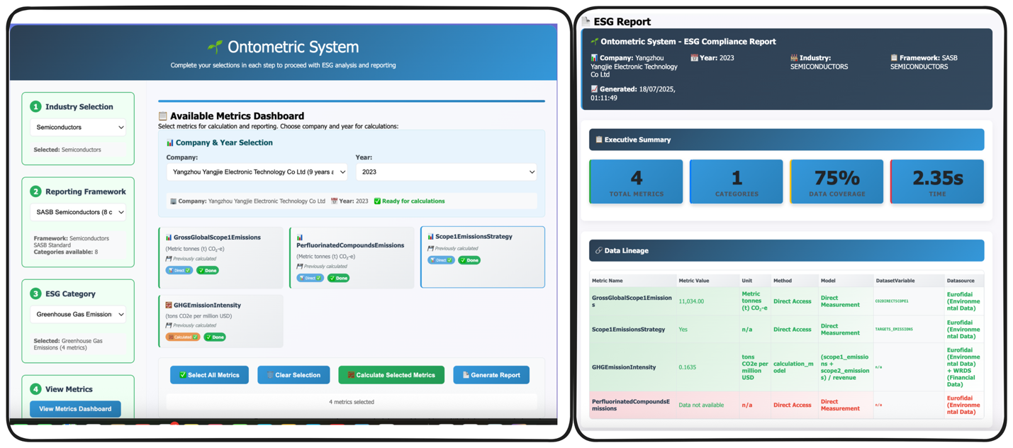
FIGURE 5.3: Interactive Web Interface showing the Ontometric System. Left: Step-by-step workflow navigation (Industry Selection, Reporting Framework, ESG Category, View Metrics). Center: Available Metrics Dashboard with company and year selection. Right: Generated ESG Compliance Report with Executive Summary and Data Lineage.

5.6.3 Workflow Execution
The workflow begins with industry selection, triggering framework identification through CQ1. When the analyst selects “Semiconductors” as the industry classification, the Knowledge Graph Service executes CQ1 to identify that SASB Semiconductor Standards apply. The system returns the framework identifier along with metadata describing its scope and disclosure requirements.
Framework selection leads to category enumeration via CQ2. For the SASB Semiconductor framework, the system identifies four primary categories: Greenhouse Gas Emissions, Energy Management, Water Management, and Waste Management. Each category is returned with its definition, applicable metrics, and any framework-specific guidance.
Category exploration reveals individual metrics through CQ3. For the Greenhouse Gas Emissions category, the system identifies metrics including Gross Global Scope 1 Emissions, Gross Global Scope 2 Emissions, and GHG Emissions Intensity. The analyst selects metrics for calculation and proceeds to company and year selection.
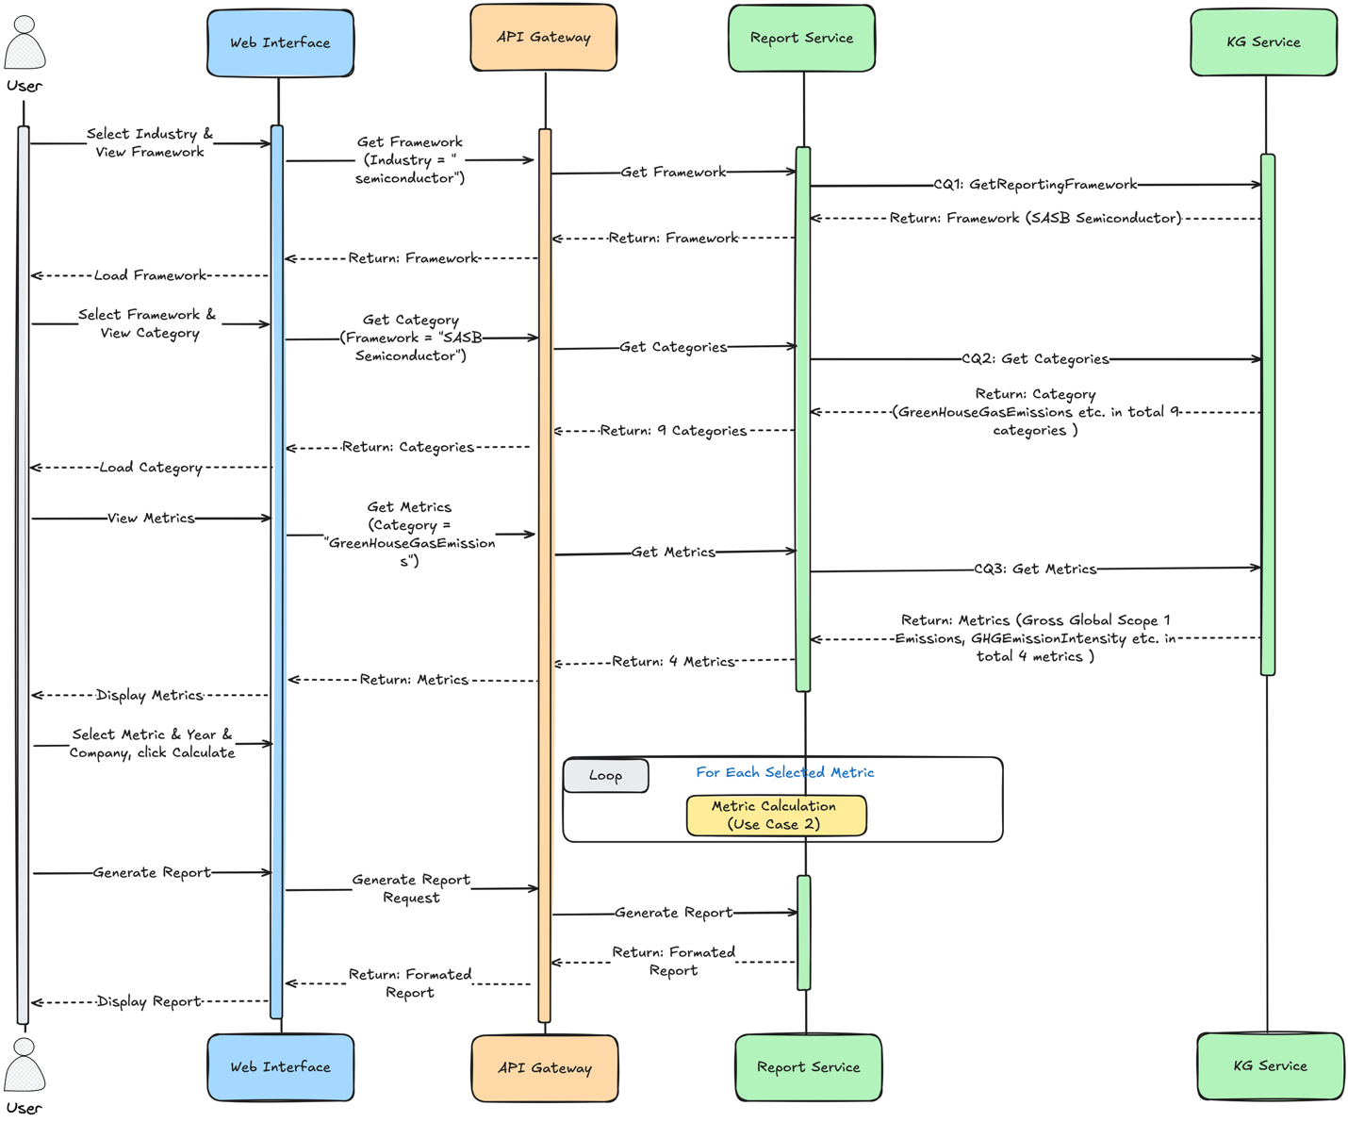
FIGURE 5.4: Sequence Diagram for Use Case 1: Report Generation. Shows the interaction flow from User through Web Interface, API Gateway, Report Service, to KG Service, demonstrating CQ1 (GetReportingFramework), CQ2 (Get Categories), and CQ3 (Get Metrics) execution.
Metric calculation proceeds through CQ4–CQ6 as illustrated in Figure 5.5. For Gross Global Scope 1 Emissions, CQ4 determines that the value is obtained directly from the dataset variable CO2DIRECTSCOPE1. For GHG Emissions Intensity, CQ4 identifies a model-based calculation requiring Scope 1 emissions, Scope 2 emissions, and revenue as inputs. CQ5 retrieves these input requirements, and CQ6 locates the GHGIntensityModel implementation for execution.
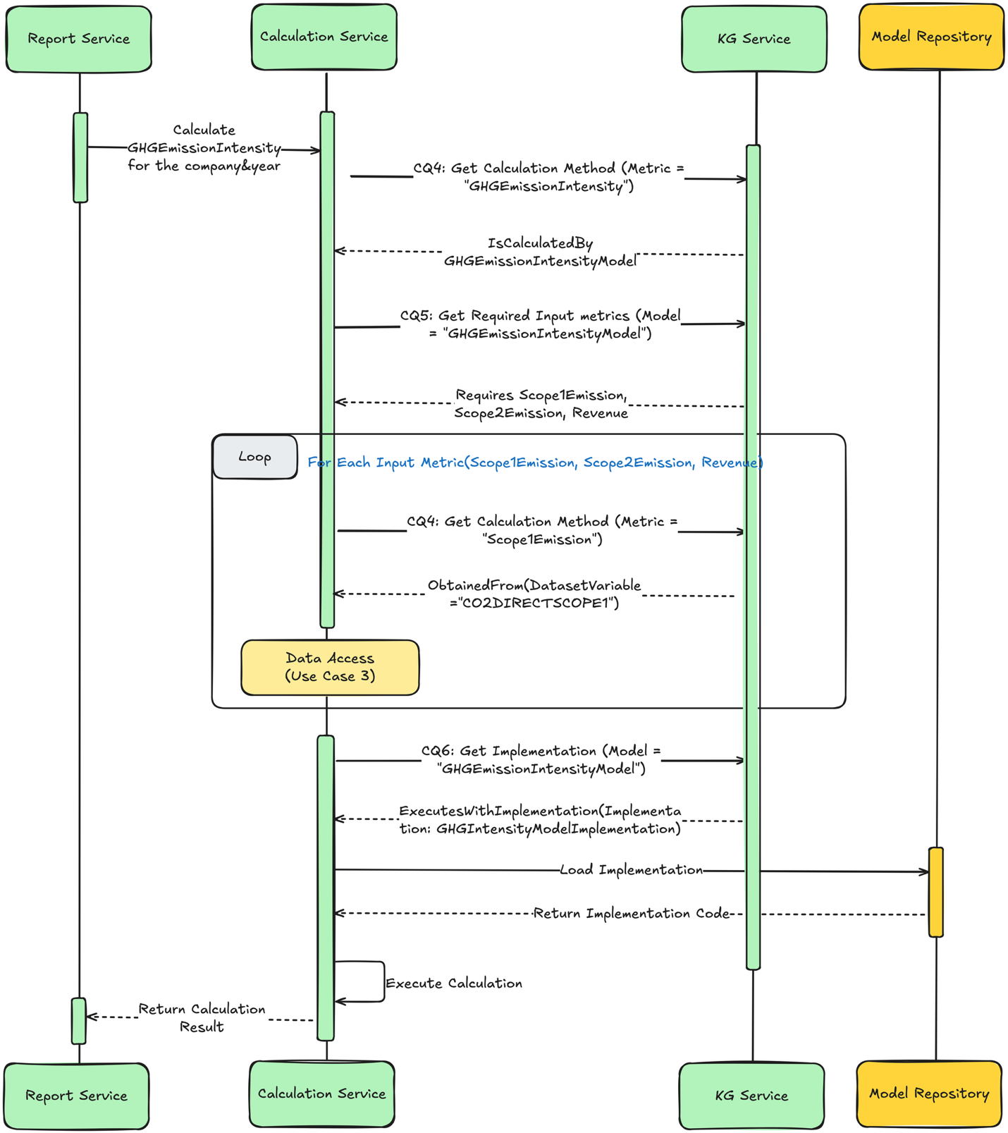
FIGURE 5.5: Sequence Diagram for Use Case 2: Metric Calculation. Shows the interaction between Report Service, Calculation Service, KG Service, and Model Repository, demonstrating CQ4 (Get Calculation Method), CQ5 (Get Required Inputs), and CQ6 (Get Implementation) execution with recursive metric resolution.
Data access through CQ7 traces each input to its original source, as shown in Figure 5.6. The system records that Scope 1 emissions data originates from the EUROFIDAI Clarity AI database with specific extraction timestamps, while revenue data comes from WRDS financial records. This provenance information accompanies the calculated metric values in the final report.
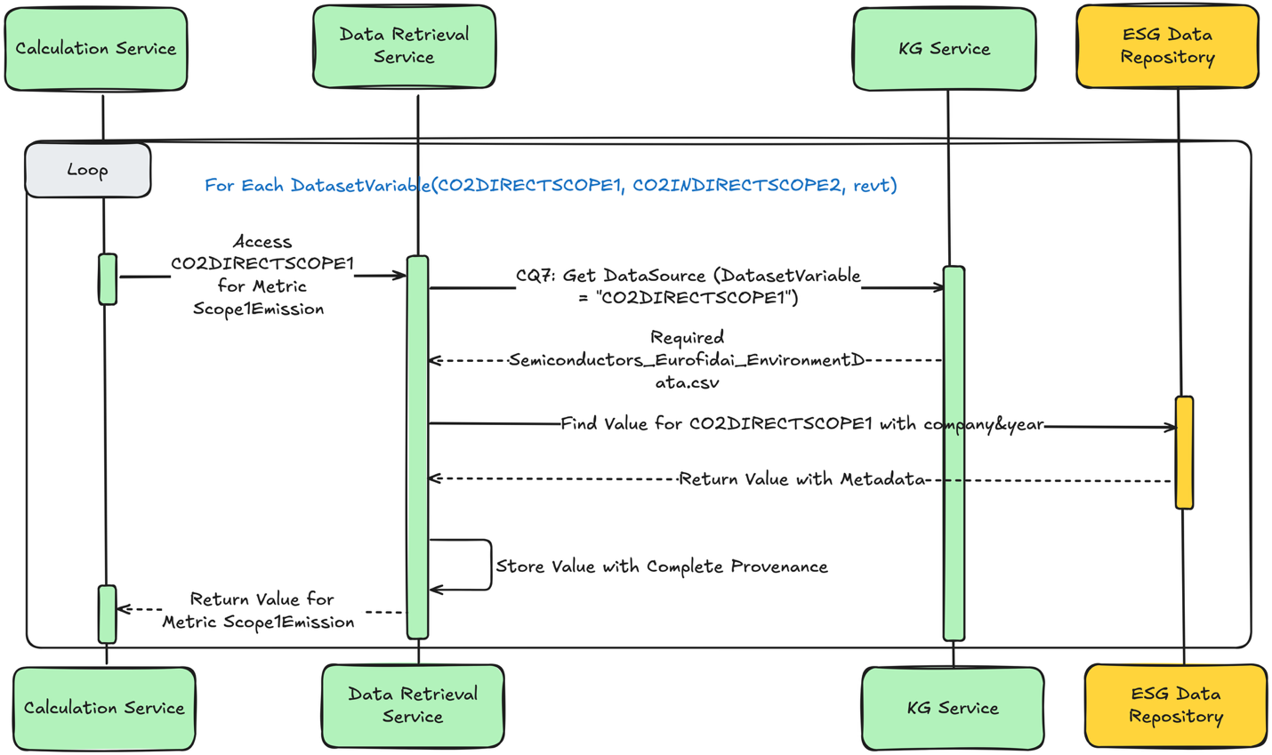
FIGURE 5.6: Sequence Diagram for Use Case 3: Data Access. Shows the interaction between Calculation Service, Data Retrieval Service, KG Service, and ESG Data Repository, demonstrating CQ7 (Get DataSource) execution with provenance metadata retrieval.

5.6.4 Generated Report Structure
The generated report includes four primary sections: Executive Summary, Metric Details, Data Lineage, and Methodology Documentation. The Executive Summary provides aggregate statistics including the number of metrics calculated, data coverage percentage, and overall computation time. The Metric Details section presents each calculated value with its unit, reporting period, and framework alignment.
The Data Lineage section provides complete traceability from reported figures to source data. For each metric, the report documents the calculation method (direct measurement or model-based), input values and their sources, intermediate calculations where applicable, and final computed values. This documentation supports audit requirements and enables stakeholders to verify reported figures.
Table 5.6 presents an excerpt from the generated report showing metric values with provenance.
Table 5.6: Sample Report Output with Provenance
Metric | Value | Unit | Method | Source
Gross Global Scope 1 Emissions | 45,230 | tCO2e | Direct | Clarity AI ESG
Gross Global Scope 2 Emissions | 128,450 | tCO2e | Direct | Clarity AI ESG
Total Energy Consumed | 892,000 | GJ | Direct | Clarity AI ESG
GHG Emissions Intensity | 0.0215 | tCO2e/$M | Model | Calculated

5.7 Evaluation

5.7.1 Evaluation Dataset
The framework was evaluated using a comprehensive real-world ESG dataset comprising 422,833 records from 40 companies across nine years. The dataset integrates two primary sources: the EUROFIDAI Clarity AI ESG database providing environmental, social, and governance metrics, and WRDS financial data supporting intensity calculations. The dataset spans the Semiconductor and Commercial Banking sectors, with 105,528 environmental records for semiconductors and 317,305 for commercial banks.
The evaluation dataset represents realistic production conditions for ESG reporting. Companies in the dataset range from large multinational corporations to mid-sized regional firms, providing variation in data completeness and metric coverage. The nine-year temporal span (2014–2022) enables assessment of trend calculation capabilities and year-over-year comparison features.
Table 5.7 summarizes the evaluation dataset characteristics.
Table 5.7: Evaluation Dataset Characteristics
Characteristic | Semiconductors | Commercial Banks
Number of Companies | 15 | 25
Temporal Coverage | 2014–2022 | 2014–2022
Total Records | 105,528 | 317,305
Environmental Metrics | 38 | 42
Social Metrics | 12 | 15
Governance Metrics | 8 | 11
Data Completeness | 78% | 82%

5.7.2 System Performance
System performance was assessed across four core services and seven semantic competency questions (CQ1–CQ7). Tests were conducted in a controlled local environment, with live API calls and backend service logs capturing response times and metadata across semantic queries, metric computations, and report generation.
The Data Retrieval Service and Knowledge Graph Service achieved excellent response times suitable for interactive use. The Data Retrieval Service averaged 10.8ms per request, enabling real-time data access even for queries spanning multiple company-years. The Knowledge Graph Service averaged 13.8ms per SPARQL query, demonstrating efficient execution of competency questions against the RDF triple store.
The Report Service delivered complete disclosures with acceptable latency. Average response time of 35.4ms for report generation reflects the service’s efficiency in aggregating metric values and provenance metadata into structured output formats. This performance supports interactive report review and iterative refinement workflows.
The Calculation Service incurred the highest latency due to runtime model execution. Average response time of 141.2ms reflects the computational overhead of model-based metric calculations, particularly for metrics with recursive dependencies requiring multiple input retrievals.
Overall, the system maintained a 100% success rate and completed full reporting workflows efficiently. End-to-end report generation for a typical company-year combination completed in under 19.5 seconds, including all metric calculations and provenance assembly. Table 5.8 summarizes the performance metrics by service.
Table 5.8: Service Performance Metrics
Service | Avg Response (ms) | Success Rate | Requests Tested
Data Retrieval Service | 10.8 | 100% | 1,000
Knowledge Graph Service | 13.8 | 100% | 1,000
Report Service | 35.4 | 100% | 500
Calculation Service | 141.2 | 100% | 500
Overall System | – | 100% | 3,000

5.7.3 TAT Assessment
To evaluate ESG-specific capabilities beyond raw performance, the framework was assessed using a qualitative framework focused on three critical properties: Transparency, Adaptability, and Traceability (TAT). While not derived from a formal standard, this framework reflects essential expectations for explainability, auditability, and resilience in ESG reporting systems. Figure 5.7 presents the complete TAT evaluation results alongside service performance metrics.
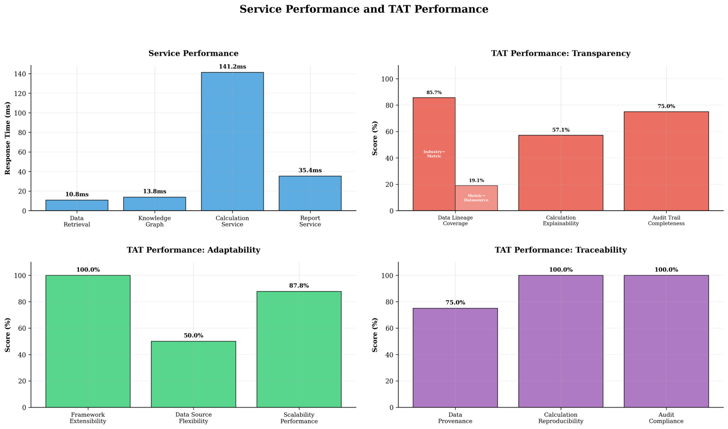
FIGURE 5.7: Service Performance and TAT (Transparency, Adaptability, Traceability) Evaluation Results. Top-left: Service response times (Data Retrieval 10.8ms, Knowledge Graph 13.8ms, Calculation 141.2ms, Report 35.4ms). Top-right: Transparency scores (Data Lineage 83.7%, Calculation Explainability 57.1%, Audit Trail 75.0%). Bottom-left: Adaptability scores (Framework Extensibility 100%, Data Source Flexibility 50%, Scalability 87.8%). Bottom-right: Traceability scores (Data Provenance 75%, Calculation Reproducibility 100%, Audit Compliance 100%).
Transparency measures whether the system exposes data lineage and explains how metric values are derived from raw sources. The evaluation assessed three dimensions: Data Lineage Coverage (percentage of metrics with complete source attribution), Calculation Explainability (availability of methodology documentation), and Audit Trail Completeness (preservation of intermediate values and timestamps). The system achieved 83.7% for Data Lineage Coverage, indicating that most metrics maintain complete provenance chains. Calculation Explainability scored 57.1% reflecting that model-based calculations expose their logic while some direct measurements lack detailed methodology. Audit Trail Completeness achieved 75.0% through consistent timestamp and source preservation.
Adaptability assesses how well the system supports new frameworks or datasets without code changes. Framework Extensibility scored 100% as new reporting frameworks can be added through knowledge graph updates alone. Data Source Flexibility achieved 50.0% reflecting that while new structured sources can be integrated, unstructured data requires additional processing pipelines. Scalability Performance scored 87.8% based on maintained response times as dataset size increased during testing.
Traceability captures the reproducibility and audit readiness of generated outputs. Data Provenance scored 75.0% with most metrics maintaining source references though some aggregated values compress lineage information. Calculation Reproducibility achieved 100% as all model-based calculations produce identical results given the same inputs. Audit Compliance scored 100% with generated reports meeting documentation requirements for the frameworks tested.
Table 5.9 summarizes the TAT assessment scores.
Table 5.9: TAT Assessment Summary
Dimension | Metric | Score (%)
Transparency | Data Lineage Coverage | 83.7
 | Calculation Explainability | 57.1
 | Audit Trail Completeness | 75.0
Adaptability | Framework Extensibility | 100.0
 | Data Source Flexibility | 50.0
 | Scalability Performance | 87.8
Traceability | Data Provenance | 75.0
 | Calculation Reproducibility | 100.0
 | Audit Compliance | 100.0
The TAT assessment reveals that the system exhibits strong support for adaptability and traceability, driven by modular service design and persistent provenance metadata. The main limitation identified was in transparency, specifically in the partial linkage between certain metrics and their raw dataset variables within the knowledge graph. This gap highlights an opportunity to enhance semantic provenance at the metric level, further improving the system’s ability to produce fully explainable ESG reports.

5.7.4 Competency Question Coverage
All seven competency questions (CQ1–CQ7) were successfully executed with complete coverage during evaluation. Each competency question was tested across multiple industry-framework-metric combinations to verify consistent behavior. CQ1–CQ3 demonstrated reliable framework and metric discovery, returning results consistent with the knowledge graph content. CQ4–CQ6 successfully distinguished between direct measurement and model-based metrics, correctly identifying calculation requirements and implementations.
CQ7 provided comprehensive data source tracing for all evaluated metrics. The query successfully resolved dataset variable to source mappings, returning source identifiers, access timestamps, and metadata for provenance documentation. While most competency questions achieved 100% success rates, CQ6 showed occasional limitations in model invocation when implementations were missing from the repository, highlighting opportunities for refinement in service integration and execution reliability.

5.8 Conclusion

5.8.1 Summary of Contributions
This chapter presented a service-oriented knowledge graph architecture designed to automate ESG reporting workflows with transparency, adaptability, and traceability. The framework operationalizes the ESGMKG ontology introduced in Chapter 4, combining semantic reasoning with modular microservices across a four-layer architecture to enable end-to-end support for data retrieval, metric computation, and report generation. The seven competency questions (CQ1–CQ7) provide structure and reasoning logic aligned with evolving ESG standards.
The implementation demonstrates the feasibility of this approach in a real-world setting. Using over 422,000 ESG datapoints spanning multiple years and 40 companies across two industries, the system supports interactive workflows, complete traceability, and structured reporting outputs. Performance evaluation confirmed responsive service delivery with the Data Retrieval Service averaging 10.8ms, Knowledge Graph Service 13.8ms, Report Service 35.4ms, and Calculation Service 141.2ms response times.
The TAT assessment validated the framework’s capabilities for regulatory compliance scenarios. Strong scores in adaptability (Framework Extensibility 100%, Scalability 87.8%) and traceability (Calculation Reproducibility 100%, Audit Compliance 100%) confirm the architecture’s suitability for production ESG reporting. Identified transparency limitations, particularly in metric-to-source linkage completeness, provide clear directions for enhancement.

5.8.2 Limitations
Several limitations of the current implementation warrant acknowledgment. First, the framework currently supports only structured data sources, limiting integration with unstructured disclosures such as sustainability narratives and qualitative governance descriptions that comprise significant portions of ESG reports. Second, while CQ6 model invocation generally succeeded, occasional failures when implementations were missing highlight opportunities for improved error handling and graceful degradation.
Third, the evaluation focused on two industry sectors with relatively mature ESG data availability. Extension to industries with sparser data coverage or more heterogeneous reporting practices may reveal additional challenges in data integration and metric computation. Fourth, the transparency assessment identified gaps in metric-to-source linkage that reduce the completeness of audit trails for certain calculated metrics.

5.8.3 Future Directions
Future work will extend the platform’s industry and framework coverage to support broader regulatory requirements. Priority extensions include GRI Standards (GRI, 2021), TCFD recommendations (TCFD, 2017), and emerging frameworks addressing biodiversity impact, diversity and inclusion, and climate scenario alignment. These extensions will leverage the ontology-driven architecture to add new frameworks through knowledge graph updates without code modifications.
Integration of unstructured disclosures using Natural Language Processing (NLP) techniques represents a significant enhancement opportunity. NLP-based extraction of ESG information from sustainability reports, press releases, and regulatory filings would expand data coverage and enable more comprehensive reporting (Brown et al., 2020). This capability would also support cross-validation of structured data against narrative disclosures.
Enhancement of metric dependency modeling and calculation auditability addresses identified transparency limitations. Planned improvements include richer semantic annotation of calculation methodologies, intermediate value preservation for complex multi-step computations, and visualization tools for exploring metric derivation chains (Bikakis & Sellis, 2016). Full integration of CQ6 execution pathways with robust error handling will improve model invocation reliability.
These developments will further position the system as a robust foundation for scalable, transparent ESG reporting in both research and applied domains. The combination of semantic knowledge representation, service-oriented architecture, and rigorous provenance tracking provides a platform capable of evolving with the rapidly changing ESG regulatory landscape while maintaining the transparency and auditability that stakeholders increasingly demand.

Figure Placeholders
- Figure 5.1: Use Case Diagram (file: figures/fig5_1_uml_use_case.png)
- Figure 5.2: Four-Layer Architecture (file: icsoc architecture.png)
- Figure 5.3: Interactive Web Interface (file: icsoc GUI.png)
- Figure 5.4: Sequence Diagram - Report Generation (file: icsoc use case report generation.png)
- Figure 5.5: Sequence Diagram - Metric Calculation (file: icsoc use case metric calculation.png)
- Figure 5.6: Sequence Diagram - Data Access (file: icsoc use case data access.png)
- Figure 5.7: TAT Evaluation Results (file: comprehensive_performance_analysis (1).png)

References
Baader, F., Calvanese, D., McGuinness, D., Patel-Schneider, P., & Nardi, D. (2003). The description logic handbook: Theory, implementation, and applications. Cambridge University Press.
Berg, F., Kölbel, J. F., & Rigobon, R. (2022). Aggregate confusion: The divergence of ESG ratings. Review of Finance, 26(6), 1315–1344.
Bikakis, N., & Sellis, T. (2016). Exploration and visualization in the web of big linked data: A survey of the state of the art. arXiv preprint arXiv:1601.08059.
Bishop, B., Kiryakov, A., Ognyanoff, D., Peikov, I., Tashev, Z., & Velkov, R. (2011). GraphDB: A semantic web database solution. Ontotext White Paper.
Brown, T., Mann, B., Ryder, N., Subbiah, M., Kaplan, J. D., Dhariwal, P., … & others. (2020). Language models are few-shot learners. Advances in Neural Information Processing Systems, 33, 1877–1901.
Buneman, P., Khanna, S., & Wang-Chiew, T. (2001). Why and where: A characterization of data provenance. International Conference on Database Theory, 316–330.
Christensen, D. M., Serafeim, G., & Sikochi, A. (2021). Why is corporate virtue in the eye of the beholder? The case of ESG ratings. The Accounting Review, 97(1), 147–175.
Cooper, M., Frame, B., & Melhus, P. (2021). Data integration challenges in ESG reporting: Industry survey results. Sustainability Accounting, Management and Policy Journal, 12(4), 761–789.
Dragoni, N., Giallorenzo, S., Lafuente, A. L., Mazzara, M., Montesi, F., Mustafin, R., & Safina, L. (2017). Microservices: Yesterday, today, and tomorrow. Present and Ulterior Software Engineering, 195–216.
Eccles, R. G., & Klimenko, S. (2020). The investor revolution. Harvard Business Review, 98(3), 106–116.
EUROFIDAI. (2023). Clarity AI ESG – Raw Data on Corporations. European Financial Data Institute. https://www.eurofidai.org/clarity-ai-esg-data
European Commission. (2022). Corporate Sustainability Reporting Directive (CSRD). Official Journal of the European Union.
Fowler, M. (2002). Patterns of enterprise application architecture. Addison-Wesley.
Gamma, E., Helm, R., Johnson, R., & Vlissides, J. (1995). Design patterns: Elements of reusable object-oriented software. Addison-Wesley.
GRI. (2021). GRI Universal Standards 2021. Global Reporting Initiative.
Harris, S., Seaborne, A., & Prud’hommeaux, E. (2013). SPARQL 1.1 query language. W3C Recommendation, 21(10), 1–106.
Hitzler, P. (2021). A review of the semantic web field. Communications of the ACM, 64(2), 76–83.
Hogan, A., Blomqvist, E., Cochez, M., d’Amato, C., De Melo, G., Gutierrez, C., … & others. (2021). Knowledge graphs. ACM Computing Surveys, 54(4), 1–37.
Horrocks, I., Patel-Schneider, P. F., Boley, H., Tabet, S., Grosof, B., & Dean, M. (2004). SWRL: A semantic web rule language combining OWL and RuleML. W3C Member Submission, 21(79), 1–31.
IFRS Foundation. (2023a). IFRS S1 General Requirements for Disclosure of Sustainability-related Financial Information.
IFRS Foundation. (2023b). IFRS S2 Climate-related Disclosures.
Knublauch, H., & Kontokostas, D. (2017). Shapes constraint language (SHACL). W3C Recommendation, 20(7).
Lenzerini, M. (2002). Data integration: A theoretical perspective. Proceedings of the ACM SIGACT-SIGMOD-SIGART Symposium on Principles of Database Systems, 233–246.
Newman, S. (2021). Building microservices: Designing fine-grained systems (2nd ed.). O’Reilly Media.
Noy, N., Gao, Y., Jain, A., Narayanan, A., Patterson, A., & Taylor, J. (2019). Industry-scale knowledge graphs: Lessons and challenges. Communications of the ACM, 62(8), 36–43.
Ozkaya, I. (2023). Modular monolithic architecture: A balanced approach for sustainable systems. IEEE Software, 40(1), 46–53.
Parnas, D. L. (1972). On the criteria to be used in decomposing systems into modules. Communications of the ACM, 15(12), 1053–1058.
Qin, M., & others. (2025). A knowledge-based framework for transparent and adaptable ESG reporting. In Proceedings of the International Conference on Service-Oriented Computing (ICSOC). (Submitted)
Richardson, C. (2018). Microservices patterns: With examples in Java. Manning Publications.
Ristoski, P., & Paulheim, H. (2016). Semantic web in data mining and knowledge discovery: A comprehensive survey. Journal of Web Semantics, 36, 1–22.
SASB. (2018). SASB Standards. SASB Foundation.
Serafeim, G., & Yoon, A. (2020). Stock price reactions to ESG news: The role of ESG ratings and disagreement. Review of Accounting Studies, 28, 1500–1530.
Sporny, M., Longley, D., Kellogg, G., Lanthaler, M., & Lindström, N. (2014). JSON-LD 1.0: A JSON-based serialization for linked data. W3C Recommendation, 16.
TCFD. (2017). Final report: Recommendations of the Task Force on Climate-related Financial Disclosures. Financial Stability Board.
WRDS. (2023). Financial Data Platform. Wharton Research Data Services. https://wrds-www.wharton.upenn.edu/

